***NOTICE PROJET SAE 105***

**BINETA DIOP TPA1**

**PROGRAMME 1 : fichier a extraire.py**

**Title : Data Sorting and Import Python Script**

*Overview :* The script reads a file and sorts data based on specific criteria. Python libraries used : numpy, os, csv, matplotlib.

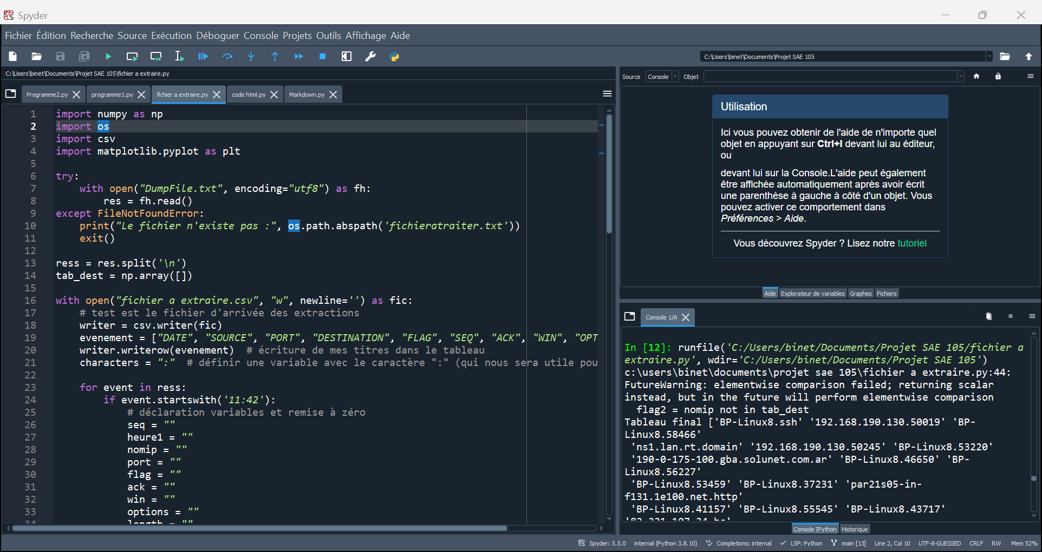

**File Reading :** The script reads a file named "DumpFile.txt" using the open function. If the file is not found, an error message is displayed.

**Data Sorting :** Data is sorted based on the presence of the character 'IP' in each line. Lines containing 'IP' are stored in a new CSV file named "data".

* Click on ‘get data from a csv file’

* Select the created file (data) and import it



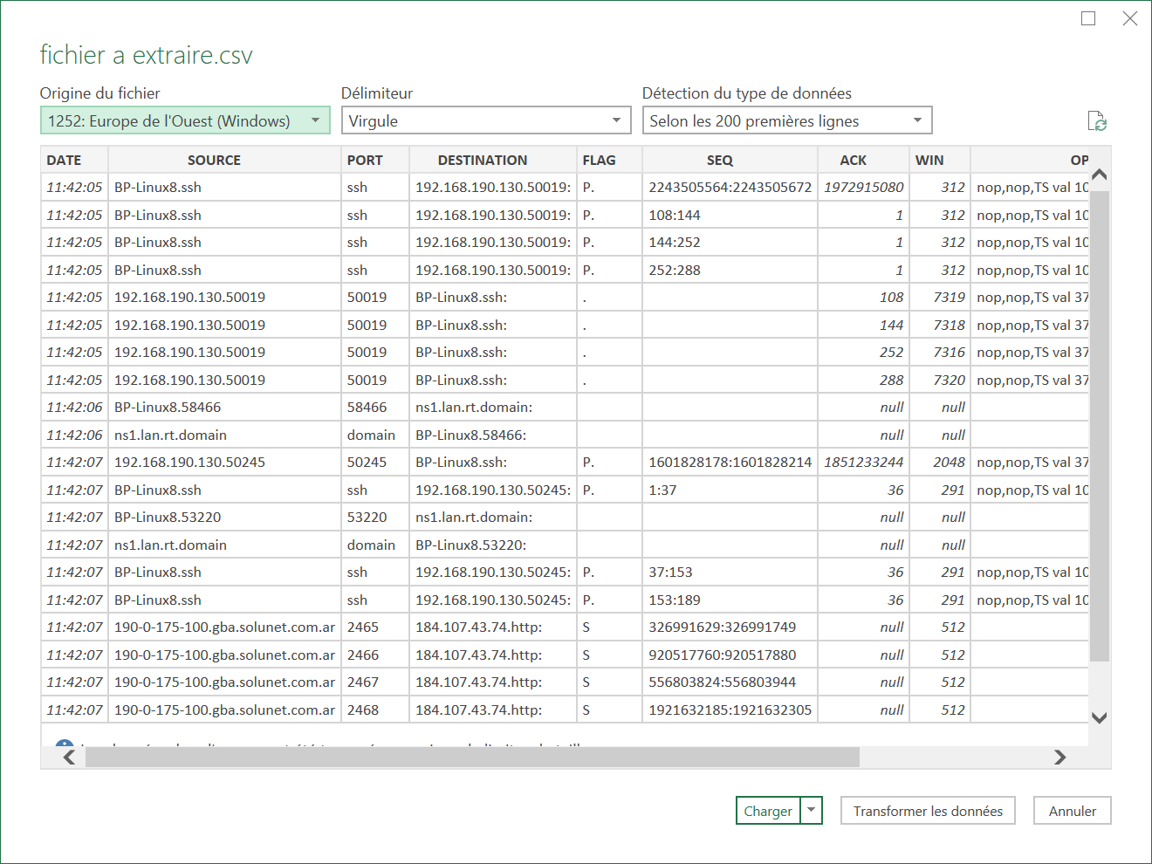

* We can load it to get it from our spreadsheet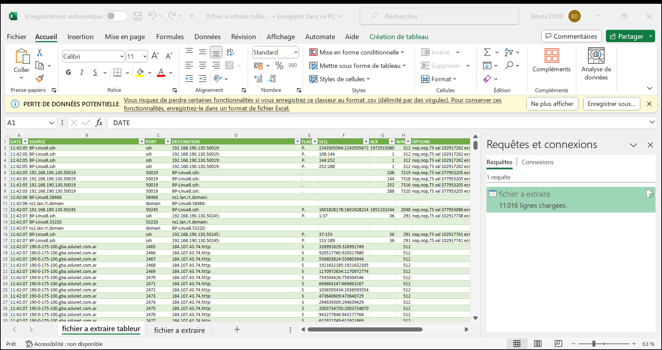

**GitHub Integration :** The script's work is shared on GitHub for collaboration. A new repository is created, and the script is uploaded for Indian colleagues to access.

**Instructions for Use :** Users are guided on how to check the creation of the CSV file "data". Instructions for opening and testing the file are provided.

**Conclusion :** The script successfully creates a sorted CSV file. Users are encouraged to share and collaborate on GitHub.

**PROGRAMME 2 : markdown.py**

**Title : Data Analysis and Visualization Python Script**

*Overview :* The script analyzes data from "DumpFile.txt" and generates visualizations. Python libraries used : csv, matplotlib. pyplot.

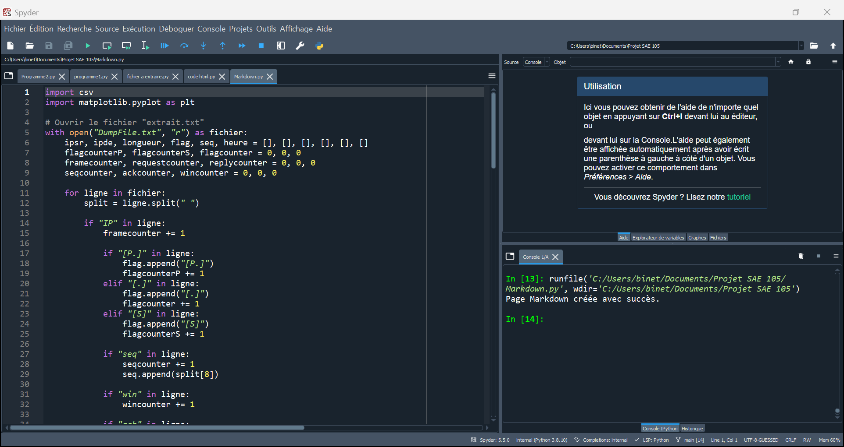

**File Reading and Analysis :** The script reads each line of the "DumpFile.txt" file. Various statistics are collected, including flags, sequences, and window sizes.

**Data Extraction :** Information such as source and destination IPs, flags, sequences, etc., is extracted. Extracted data is written to a new CSV file named "donnees.csv".

**Data Visualization :** Two pie charts are generated using Matplotlib.

* Flags Distribution (PUSH, SYN, ACK)
* Request and Reply Distribution

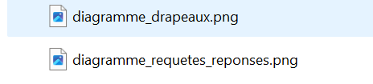

**Page Markdown Generation :** A Markdown page is created with key information and statistics. Markdown file is saved ! as "data.md".

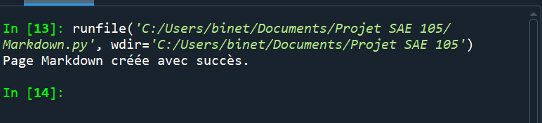

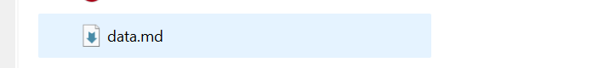

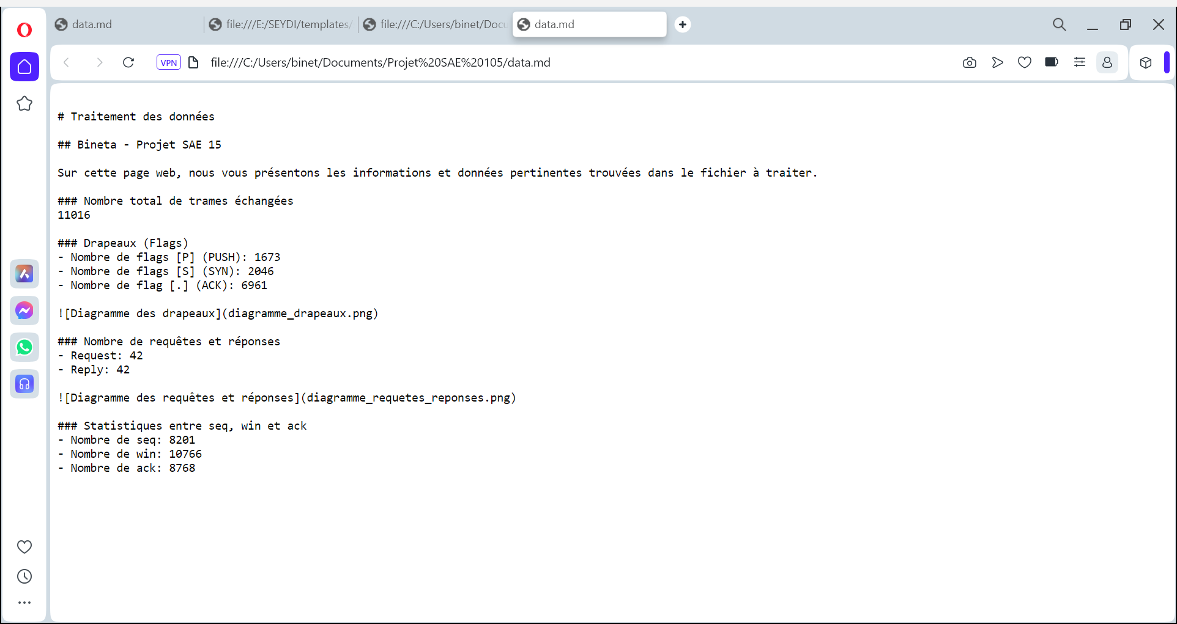

**Data Saving and Conclusion :** Data is saved in CSV files ("donnees.csv" and "Stats.csv"). Conclusion slide with a summary of the script's functionality.

